Case 6-Afr-Mali-Djenne-Dogon-Kanaga Passport Mask-late 19th c
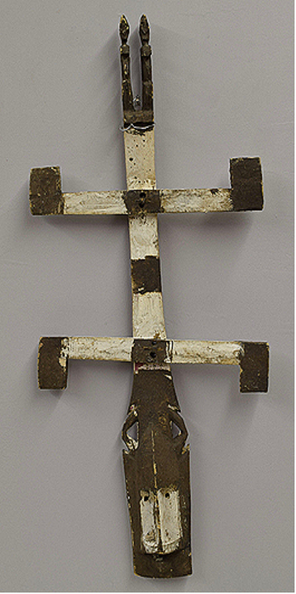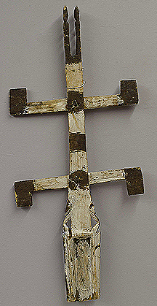
Figs. 1-2. Mali-Djenne-Dogon-Kanaga Passport Mask-late 19th c
Case no.: 6
Accession Number:
Formal Label: Mali-Djenne-Dogon-Kanaga Passport Mask-late 19th c
Display Description:
This late 19th c Dogon Kanaga “Passport” Mask from Djenné, Bandiagara Cliffs, Mali. The act of carving Kanaga masks holds as much spiritual significance as the rituals in which the masks are worn. A Dogon Kanaga Mask offers a rare look at the Dogon’s highly secretive methods of mask making. Although these ceremonies are now frequently performed for the public, the sacred meaning of the Kanaga is retained by the Dogon villagers who fear, respect, and depend on the power of the mask. The Kanaga consists of a face mask with a long center post jutting up from the top. The post is crossed left to right by two short bars. The cross bars each have two smaller wooden slats referred to as arms. The lower bar has two arms pointing downwards (symbolizing Earth) while the top bar features two arms pointing upwards (symbolizing Sky). This alludes to the metaphoric Dogon cosmology that is also present in the Nyerum-Nommo wood sculptures.
Geographical Area: Mali- Djenné-Djeno
LC Classification: DT551.42
Date or Time Horizon: 19th c
Geographical Area: site of Djenné-Djeno, Mali, on the flood plain of the Bani River, 3 km (1.9 mi) s of modern town.

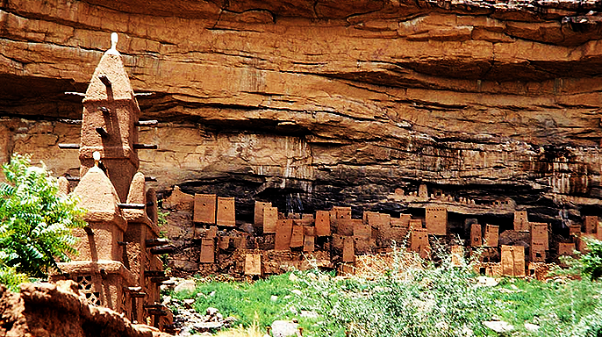
Fig. 3. Cliff dwellings of the Tellem along the Bandiagara Escarment, Mali, with a Dogon mosque to the
left after http://www.apsaidal.com/wp
content/uploads/2017/03/Tellem_Dwelling_Bandiagara_Escarpment_Mali.jpg
Map:

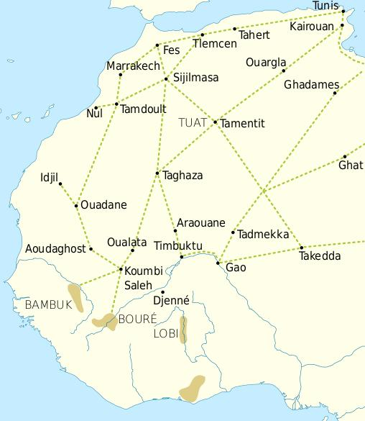
Fig. 4. Trade routes of the Western Sahara c. 1000-1500, showing the most direct route for the Black Death from Tripoli to Ghadames to Gaoto Timbukti to the Bandiagara Escarpment from Tieme Ciewe to Djenne ca 1348-1349. This indicates that the diffusion of the Black Death would have been expeditious, since these trade routes were in operation in the 1340’s. Goldfields are indicated by light brown shading. After https://i.pinimg.com/564x/69/15/ce/6915ce6f4fd34025787fe59bd44f9eae.jpg
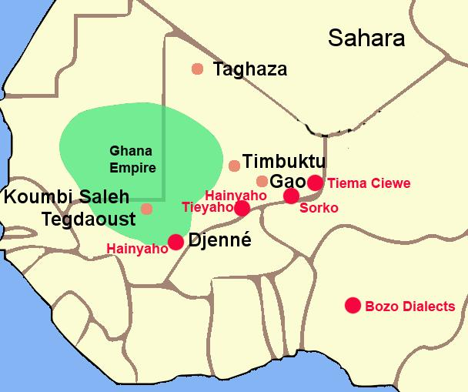
Fig. 5. The Ghana Empire 1000-1400 CE showing the ethnolinguistic groups along the Niger River. After https://i.pinimg.com/564x/c6/a7/9b/c6a79b7443105f363ff965ebf420b7fd.jpg
Formal Label: Mali-Djenné Djeno-Bozo People-Sorko Culture-14th c
GPS coordinates: 13° 53′ N, 4° 32′ W
Cultural Affiliation: Dogon
Media: wood, kaolin paste, charcoal, rawhide.
Dimensions:
Weight:
Condition: original
Provenance: Bandiagara Escarpment
Discussion:
Dogon dancers perform with Kanaga masks at 'Dama' ceremonies which honor and commemorate the dead. Half-sized masks, too small to be worn, replicate the forms of masks worn in performances. Like their larger counterparts they are powerful charms, filled with spirit, with potential for good or evil. However, while the full-sized masks are made for display in public ceremonies, these “Passport” masks are not used in performances and are sequestered in the local compound on a personal shrine. When the owner of this mask was travelling, it was carefully packed with other personal belongings and carried with care like a passport, hence the term “Passport” mask was coined.
Djenne 220 miles (354 km) south of Timbuktu was founded by the Bozo people in the 13th century as a fishing village. In the early 14th c the Soninke People made it into a trading center supplying Timbuktu with food, cotton, gold, cola nuts, and slaves in exchange for salt and North African trade described by Leo Aericanus in 1512-13. At the time of the Black Death in ca 1348 residents deserted the city and established Djenne-Djeno, only 2 miles (3 km) distant, which remained an independent city (outside the jurisdiction of the various empires rising and falling around it), and one seemingly without imperial aspirations, until Sunni Ali Ber conquered it in the 1470s. Djenne’s location provided some security for traders, as it was surrounded by the two rivers for nearly half of each year. However, the protection of the rivers did not prevent more powerful invaders such as the Mali in the 14th century, the Mossi in the mid-15th century, and the Songhai under Sunni Ali Ber in 1491 from laying siege to the city, nor from Moroccan invaders in the 1500s.
References:
Bouju, Jacky. 1984. Graine de l'homme, enfant du mil. Sociétés Africaines, 6. Paris: Société d'Ethnographie.
Bouju, Jacky. 1991. Comments. In: Van Beek, Walter. “Dogon restudied: A field evaluation of the
work of Marcel Griaule,” Current Anthropology 32, 2: 139-168. S. 159-160.
Calame-Griaule, Geneviève. 1968. Dictionnaire dogon. Dialecte Toro. Langue et civilisation. Langues et littératures de l’Afrique Noire, Bd. 4. Paris: Klincksieck.
Calame-Griaule, Geneviève/ 1987 [1965]. Ethnologie et langage. La parole chez les Dogon. Paris: Institut d’Ethnologie.
Calame-Griaule, Geneviève. 1991. “On the Dogon restudied,” Current Anthropology 32,5: 575-577.
Dieterlen, Germaine. 1941. Les âmes des Dogons. Paris: Institut d’Ethnologie.
Dieterlen, Germaine.1982. Le titre d'honneur des Arou. Dogon, Mali. Mémoires de la Société des
Africanistes. Paris: Société des Africanistes.
Dieterlen, Germaine. 1989. “Masks and mythology among the Dogon,” African Arts 22,3: 34-43.
Douglas, Mary. 1967. “If the Dogon…,” Cahiers d’Études Africaines 7,4: 659-672.
Douglas, Mary. 1968. “Dogon culture – profane and arcane,” Africa 38: 16-25.
Griaule, Marcel. 1938. Masques dogons. Paris: Institut d’Ethnologie.
Griaule, Marcel. 1948. Valeur symbolique du vêtement Dogon. Revue d’esthétique 1: 195.
Griaule, Marcel. 1975 [1948]. Dieu d’eau. Entretiens avec Ogotemmêli. Paris: Fayard.
Griaule, Marcel. 1980 [1970]. Schwarze Genesis. Ein afrikanischer Schöpfungsbericht. Frankfurt:
Suhrkamp
Griaule, Marcel und Germaine Dieterlen 1965. Le renard pâle. Paris: Institût d’Ethnologie.
Jolly, Eric. 2003. Le pouvoir en miettes. Récits d'intronisation d'un hogon. Pays dogon, Mali.
Classiques Africains, 29. Paris: Classiques Africains.
Jolly, Eric. 1998-99. « Chefs sacrés, chefs de guerre, deux pôles du pouvoir, » Clio en Afrique 5.
Mayor Anne, Eric Huysecom, Alain Gallay et al. 2005. “Population dynamics and paleoclimate over the past 3000 years in the Dogon Country, Mali,” Journal of Anthropological Archaeology 24: 25-61.
N’Diaye, Francine. 1971. Iconologie des poulies de métier à tisser dogon. Objets et Mondes 11: 355-370.
N’Diaye, Francine. 1995. L’art du pays dogon dans les collections du Musée de l’Homme. Zürich: Museum Rietberg.
Van Beek, Walter. 1991. “Dogon restudied. A field evaluation of the work of Marcel Griaule,” Current Anthropology 32, 2: 139-168.
Van Beek, Walter. 1992. On myth as science fiction. Current Anthropology 33,2: 214-216.
Van Beek, Walter. 2003a. La vie et l’au-delà. Organisation sociale des Dogon. In: Bedaux, Rogier M.A.
und J. Diderik van der Waals (Hg.). Regards sur les Dogon du Mali. Leiden: Rijksmuseum voor Volkenkunde, Gent: Éditions Snoeck. S. 93-94.
Van Beek, Walter. 2003b. La religion des Dogon. In: Bedaux, Rogier M.A. und J. Diderik van der Waals (Hg.). Regards sur les Dogon du Mali. Leiden: Rijksmuseum voor Volkenkunde, Gent: Éditions Snoeck. S. 95-103.
Van Beek, Walter. 2005. Haunting Griaule. Experiences from the restudy of the Dogon. History in Africa 31: 43-68.
Van Beek, Walter und Pietke Banga 1990. The Dogon and their trees. In: David Parkin und Elisabeth
Croll. Cultural understandings of the environment. London: School of Oriental and African Studies.

